MAY CHIEF’S REPORT
Skagit County Fire District #17 Fire Chief Olivia Cole

Weekly Training Drills
May 7th Firefighting Skills / Helo Pad (6)
May 7th OTEP #2 for certified EMT’s (9)
May 14th Helo Operations with Airlift NW (17)
May 21st Training on the new AED’s / Lithium Battery (17)
May 28th Wildland Progressive Hose (17)

Off Island Training
EMT instructor training for OTEP off island (1)

On Island Training/Meetings/Detail Jobs

May 1st-31st Paramedic Pick ups (14)
May 28th SCBA Battery Checks (1)
May1-31st Hospice Nurse Pick up (1)
May 23,27& 30th FireWise Chipping (4)
May 31st Table at the Art Tour (2)

Fire/Med Calls for May 2020-2024

2020 10
2021 8
2022 6
2023 9
2024 8

Fire/Med Calls for March 2025

2025 12
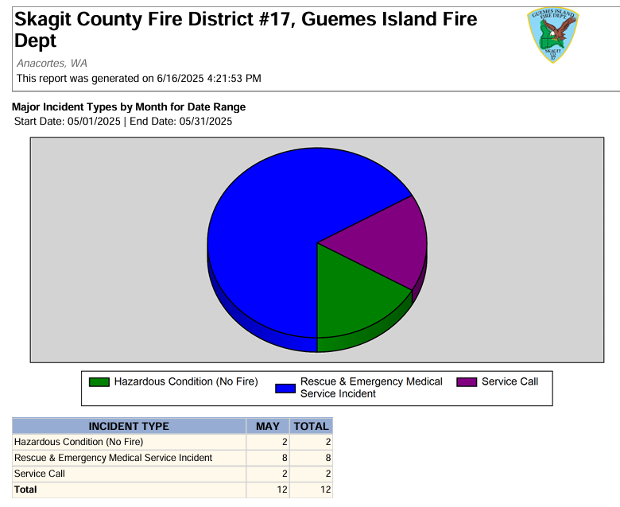

Administrative

I recently met with the Sea Western representative and tried on different types of bunker gear. I want to present two quotes tonight.
New recruit paperwork.
Tom Fouts retirement.
Coming Up!
Barbeque for Tom on June 25th during drill.
July 4th Parade and Park activities.

